

DLD Lab-01

Introduction to DLD & Lab Equipment



January 26, 2023

NATIONAL UNIVERSTIY OF COMPUTER AND EMERGING SCIENCES, FAST- Peshawar Campus

Department Of Computer Science

Instructor: Mazhar Iqbal

EL227 – Digital Logic Design-Lab

SEMESTER SPRING 2021

Contents

1. Why DLD 2

▪ What is Analog Signal and Digital Signal? 2

▪ What is Logical gate? 2

▪ What are states of binary number? 2

▪ What is truth table? 2

2. Logic Gates 3

▪ Objective of Gate 3

▪ Logical Expression 3

▪ Procedure 3

▪ Logical Symbol 3

▪ Gate Operations 3

▪ Truth Table 3

▪ IC Number 3

▪ IC Connection Diagram. 3

▪ Circuit Diagram 3

3. What are Digital Integrated IC’s 3

4. Analog/Digital Training System (ETS 500) 4

5. What is a breadboard? What is the purpose of this board? How is a breadboard used? 5

6. Building the Circuit on Breadboard 7

7. Common Causes of Problems in DLD LAb 8

8. Practical of AND, OR, NOT on logic.ly 8

# Why DLD

**Digital Logic Design** is used to develop hardware, such as **circuit** boards and microchip processors. This hardware processes user input, system protocol and other data in computers, navigational systems, cell phones or other high-tech systems.

**Questions:**

### What is Analog Signal and Digital Signal?

An **analog signal** signifies a continuous **signal** that keeps changes with a time period. A **digital signal** signifies a discrete **signal** that carries binary data and has discrete values. **Analog signals** are continuous sine waves. **Digital signal** is square waves.

### What is Logical gate?

 A **logic gate** accepts inputs and then outputs a result based on their state”

### What are states of binary number?

0 or 1, High or Low, Closed or Open

### What is truth table?

A **truth table** is a breakdown of a logic function by listing all possible values the function can attain. Such a **table** typically contains several rows and columns, with the top row representing the logical variables and combinations, in increasing complexity leading up to the final function.

# Logic Gates

**Gates Features:**

AND gate, OR Gate, NOT Gate, NAND Gate, NOR Gate, XOR gate, XNOR gate.

### Objective of Gate

### Logical Expression

### Procedure

### Logical Symbol

### Gate Operations

### Truth Table

### IC Number

### IC Connection Diagram.

### Circuit Diagram

Three basic gates: AND, OR and NOT gate

There are Two Special Purpose Gate. (Exclusive Or and Exclusive Nor Gate)

# What are Digital Integrated IC’s

* 1. **Digital Integrated IC’s :**

Digital ICs are a collection of resistors, diodes and transistors fabricated on a single piece of semiconductor material usually silicon and referred to as “chip”. The chip is enclosed in a protective plastic or ceramic package with pins extended out for connecting the IC to other devices. The most common type of package is a dual-in-line package (DIP) as shown in figure 1.2.

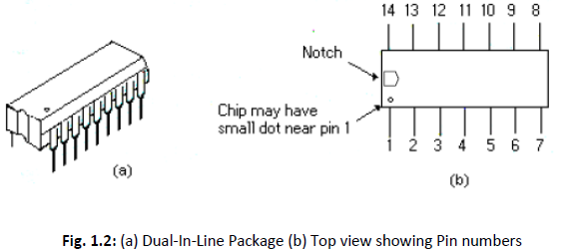

* + The pins are numbered counterclockwise when viewed from the top of the package with respect to an identifying notch or dot at one end of the chip. The DIP below is a 14-pin package. 16, 20, 24, 28, 40 and 64 pin packages are also available.
  + The fabricated resistors, diodes and transistors reside in the chip are called logic gates. Different chip may contain different amount of these logic gates.
  + Digital ICs are often categorized according to their circuit complexity as measured by the number of equivalent logic gates in an IC. There are currently five standard levels of complexity as in Table 1.1.

|  |  |  |
| --- | --- | --- |
| **Complexity** | **Approx. gates per chip** | **Typical products** |
| **Small scale integration (SSI)** | Less than 12 | Logic gates, flip flops |
| **Medium scale integration (MSI)** | 12 to 99 | Adders, Counters, |
| **Large scale integration (LSI)** | 100 to 9999 | ROM, RAM, 8 bit |
| **Very large scale integration (VLSI)** | 10, 000 to 99, 999 | 16 and 32 bit |
| **Ultra large scale integration (ULSI)** | 100, 000 to more | 64 bit microprocessors,  special processors |

# Analog/Digital Training System (ETS 500)

**The Analog/Digital Training System consists of DC power supply, breadboard, pulse generator and a digital probe. Useful features include:**

**1. DC Power Supply:**

 Fixed DC Outputs: +5V & -5V

Variable DC Outputs: +3V to +15V, -3V to -15V

**2. Breadboard:**

Terminal strips arranged for easy connection of standard ICs

**3. Pulse Generator:**

Variable duty cycle: (set to 50%)

Frequency range: 1Hz – 10MHz

Amplitude: 0VP-P - 10 VP-P

**4. Digital Probe**

To find any type of bug/fault in the circuit.

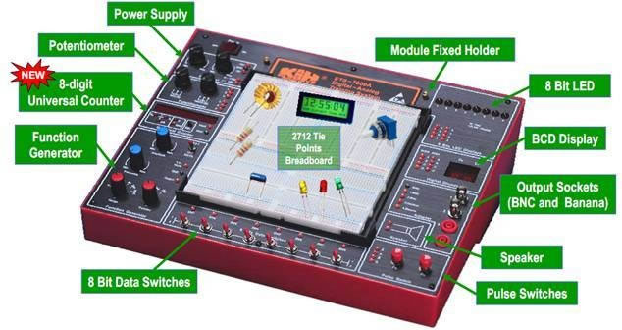

# What is a breadboard? What is the purpose of this board? How is a breadboard used?

* The breadboard consists of two terminal strips and two bus strips (often broken in the center).
* Each bus strip has two rows of contacts.
* Each of the two rows of contacts is node. That is, each contact along a row on a bus strip is connected together (inside the breadboard).
* Bus strips are used primarily for power supply connections, but are also used for any node requiring a large number of connections.
* In the example of breadboard shown in figure 1.1, each terminal strip has 60 rows and 5 columns of contacts on each side of the center gap.

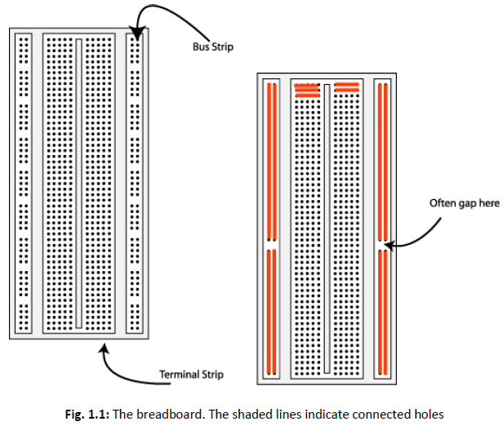

* Each row of 5 contacts is a node. You will build your circuits on the terminal strips by inserting the leads of circuit components into the contact receptacles and making connections with 22-26 gauge wire. There are wire cutter/strippers and a spool of wire in the lab. It is a good practice to wire +5V and 0V power supply connections to separate bus strips.
* The 5V supply **MUST NOT BE EXCEEDED** since this will damage the ICs (Integrated circuits) used during the experiments. Incorrect connection of power to the ICs could result in them exploding or becoming very hot.

# Building the Circuit on Breadboard

Throughout these experiments, we will use TTL chips to build circuits. The steps for wiring a circuit should be completed in the order described below:

* 1. Make sure the power is off before you build anything!
  2. Connect the +5V and ground (GND) leads of the power supply to the power and ground bus strips on your breadboard. Before connecting up, use a voltmeter to check that the voltage does not exceed 5V.
  3. Plug the chips you will be using into the breadboard. Point all the chips in the same direction with pin 1 at the upper-left corner. (Pin 1 is often identified by a dot or a notch next to it on the chip package)
  4. Connect +5V and GND pins of each chip to the power and ground bus strips on the breadboard.
  5. Select a connection on your schematic and place a piece of hook-up wire between corresponding pins of the chips on your breadboard. It is better to make the short connections before the longer ones. Mark each connection on your schematic as you go, so as not to try to make the same connection again at a later stage.
  6. Consult your instructor to check the connections, **before you turn the power on**.
  7. If an error is made and is not spotted before you turn the power on. Turn the power off immediately before you begin to rewire the circuit.
  8. At the end of the laboratory session, collect your hook-up wires, chips and all equipment and return them to the demonstrator.
  9. Tidy the area that you were working in and leave it in the same condition as it was before you started.
  10. Select a connection on your schematic and place a piece of hook-up wire between corresponding pins of the chips on your breadboard. It is better to make the short connections before the longer ones. Mark each connection on your schematic as you go, so as not to try to make the same connection again at a later stage.
  11. Consult your instructor to check the connections, **before you turn the power on**.
  12. If an error is made and is not spotted before you turn the power on. Turn the power off immediately before you begin to rewire the circuit.
  13. At the end of the laboratory session, collect you hook-up wires, chips and all equipment and return them to the demonstrator.
  14. Tidy the area that you were working in and leave it in the same condition as it was before you started.

# Common Causes of Problems in DLD Lab

* Not connecting the ground and/or power pins for all chips.
* Not turning on the power supply before checking the operation of the circuit.
* Leaving out wires.
* Plugging wires into the wrong holes.
* Driving a single gate input with the outputs of two or more gates.
* Modifying the circuit with the power on.
* In all experiments, you will be expected to obtain all instruments, leads, components at the start of the experiment and return them to their proper place after you have finished the experiment.

# Practical of AND, OR, NOT on logic.ly